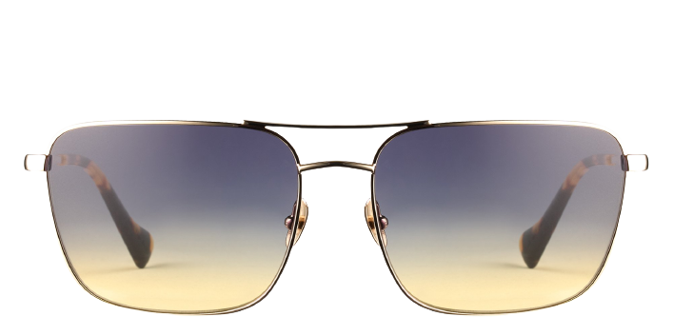 **Mitchell Sun**

Product information

|  |  |
| --- | --- |
| **Brands** | Kits |
| **Gender** | Unisex |
| **Lenses** | Prescription lenses available |
| **Material** | Metal |

Description

**KITS created the Mitchell sunglasses for the wearer with dignified tastes and a preference for top quality eyewear. These slim metal frames are lightweight and corrosion resistant, with a sturdy double bridge for a classic look. The skull temples curve gently inward for added stability behind the ear and feature coated tips for a comfortable feel. If your personal aesthetic lies between conservative uptown and edgy downtown, these Mitchell sunglasses from KITS are a smart option. Please note these frames fit large and are best suited to those with wider faces.**

|  |
| --- |
| What You’ll Get   * **Optical grade sun lenses with 100% UV protection** * **Soft case and cleaning cloth.** * **Unconditional 30 days return policy.  Free return shipping.** |